Madayag WILFORD SAM G
BSCOME 4

Singleton Pattern
In the expense-tracker application, the Singleton pattern is used in the database configuration (/config/database.js) to ensure that only one database connection instance exists throughout the application. Since multiple components such as models and controllers need database access, creating multiple connections would waste resources and risk data inconsistency. The Singleton pattern solves this by providing a single, globally accessible database instance that is created only once and reused everywhere.

Code Implementation
// /config/database.js
let dbInstance = null;

function connectDatabase() {
if (!dbInstance) {
dbInstance = {
connect: () => console.log("Database connected")
};
}
return dbInstance;
}

module.exports = connectDatabase();

UML PLANT DIAGRAM
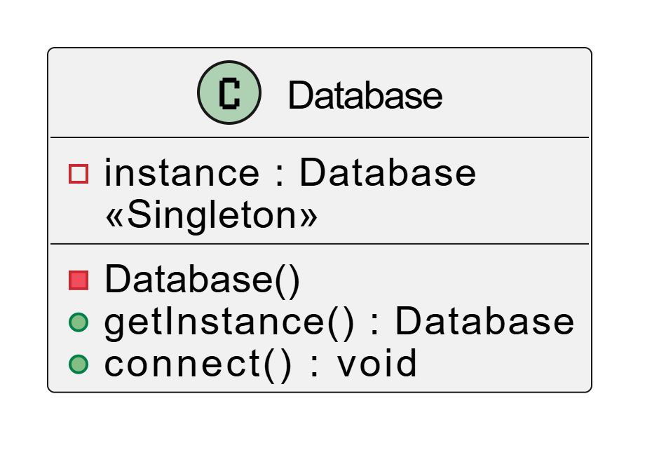

Factory Pattern
The Factory pattern is used to centralize the creation of expense objects. Instead of creating expense instances directly inside the controller, a factory class determines how expense objects are constructed. This reduces coupling between the controller and expense classes and makes it easy to introduce new expense types without modifying existing logic.
Code implementation

// /models/ExpenseFactory.js
class Expense {
constructor(amount, category) {
this.amount = amount;
this.category = category;
this.date = new Date();
}
}

class ExpenseFactory {
static createExpense(category, amount) {
return new Expense(amount, category);
}
}

module.exports = ExpenseFactory;

UML PLANT DIAGRAM

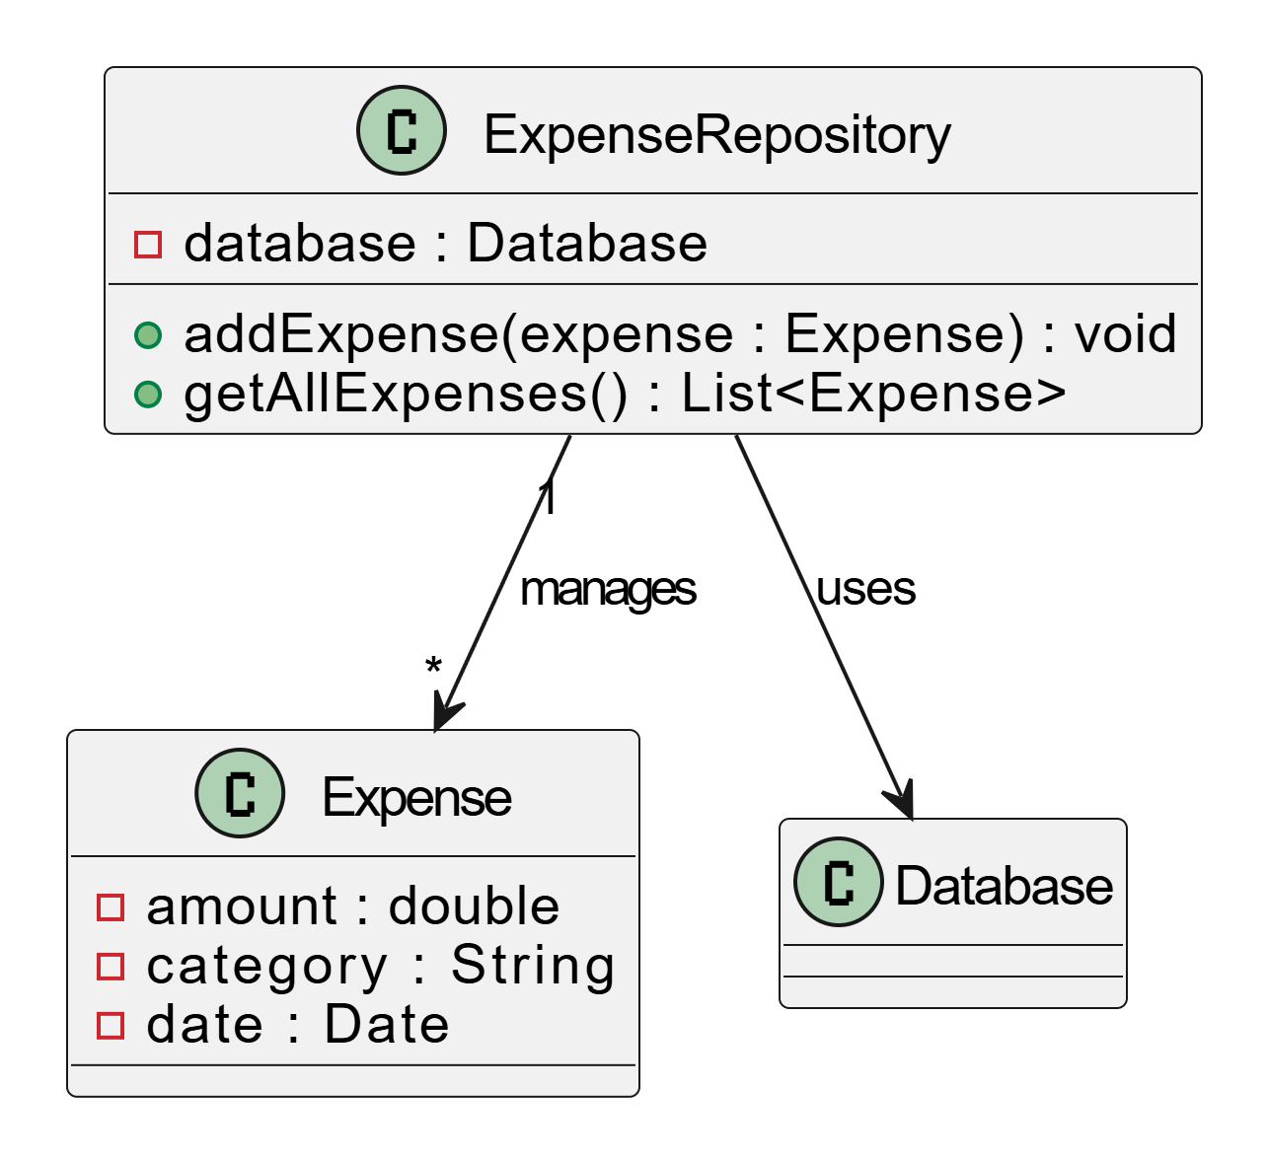

Factory Pattern
The Factory pattern is used to centralize the creation of expense objects. Instead of creating expense instances directly inside the controller, a factory class determines how expense objects are constructed. This reduces coupling between the controller and expense classes and makes it easy to introduce new expense types without modifying existing logic.

Code implementation
// /models/ExpenseFactory.js
class Expense {
constructor(amount, category) {
this.amount = amount;
this.category = category;
this.date = new Date();
}
}

class ExpenseFactory {
static createExpense(category, amount) {
return new Expense(amount, category);
}
}

module.exports = ExpenseFactory;
PLANT UML DIAGRAM
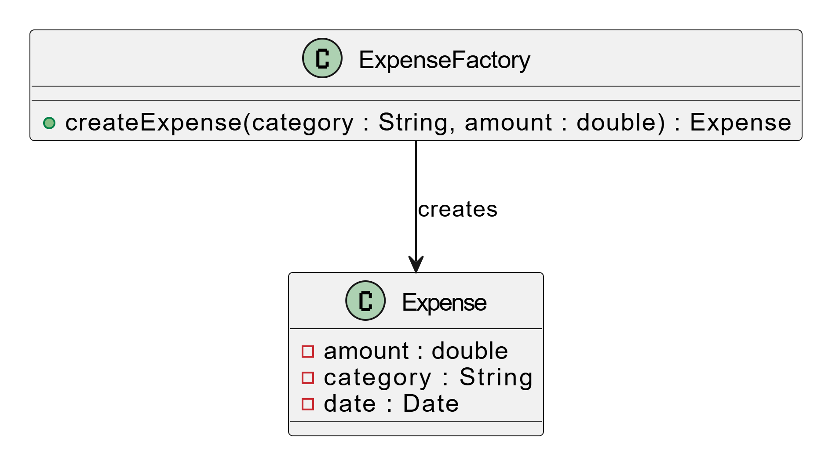

Strategy Pattern
In the expense-tracker application, the Strategy pattern is used to support different ways of calculating or processing expenses, such as calculating daily totals, monthly totals, or category-wise totals. Instead of hard-coding these algorithms inside the controller, the Strategy pattern encapsulates each calculation method into a separate strategy class. This allows the controller to switch between different calculation strategies at runtime without modifying its core logic, improving flexibility and adherence to the Open/Closed Principle.

// /strategies/ExpenseStrategy.js

class ExpenseStrategy {

calculate(expenses) {

throw new Error("Method must be implemented");

}

}

module.exports = ExpenseStrategy;

UML PLANT DIAGRAM
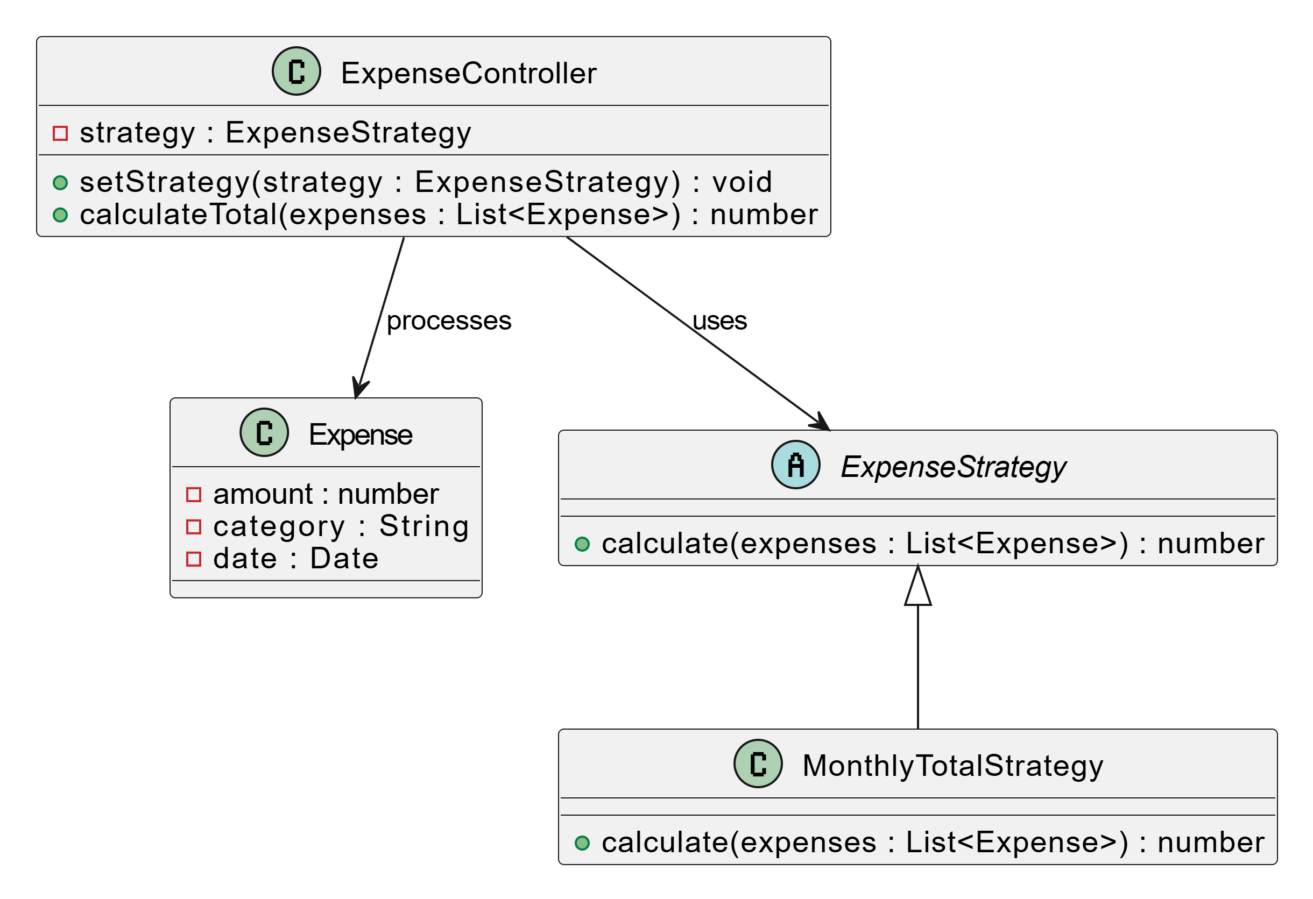

Observer patern
In the expense tracker, whenever an expense is added, updated, or deleted, the UI must refresh automatically (expense list, total amount, charts). The Observer Pattern enables this by allowing the controller (Subject) to notify all views (Observers) whenever expense data changes, without tight coupling between them.

// /controllers/ExpenseController.js
class ExpenseController {
constructor(repository) {
this.repository = repository;
this.observers = [];
}

subscribe(observer) {
this.observers.push(observer);
}

notify(expenses) {
this.observers.forEach(observer => observer.update(expenses));
}

addExpense(expense) {
this.repository.addExpense(expense);
const expenses = this.repository.getAllExpenses();
this.notify(expenses);
}
}

module.exports = ExpenseController;

UML PALNT DIAGRAM
